**DAILY ONLINE ACTIVITIES SUMMARY**

|  |  |  |  |  |  |  |  |  |
| --- | --- | --- | --- | --- | --- | --- | --- | --- |
| **Date:** | **10/06/2020** | | | | | **Name:** | **Lavanya D M** | |
| **Sem & Sec** | **4th & ‘A’** | | | | | **USN:** | **4al18cs041** | |
| **Online Test Summary** | | | | | | | | |
| **Subject** | | **OOC** | | | | | | |
| **Max. Marks** | | **30** | | **Score** | | | **4** | |
| **Certification Course Summary** | | | | | | | | |
| **Course** | **VMware lab** | | | | | | | |
| **Certificate Provider** | | | **Bitdegree** | | **Duration** | | | **1 week** |
| **Coding Challenges** | | | | | | | | |
| **Problem Statement:1:** Given a matrix, the task is to print the boundary elements of the matrix and display their sum. **2)** Java Program to find the longest repeating sequence in a string string:acbdfghybdf | | | | | | | | |
| **Status: complied** | | | | | | | | |
| **Uploaded the report in Github** | | | | | **Yes** | | | |
| **If yes Repository name** | | | | | <https://github.com/lavanyamurthi/lockdown-coding> | | | |
| **Uploaded the report in slack** | | | | | **Yes** | | | |

Online Test Details: (Attach the snapshot and briefly write the report for the same)

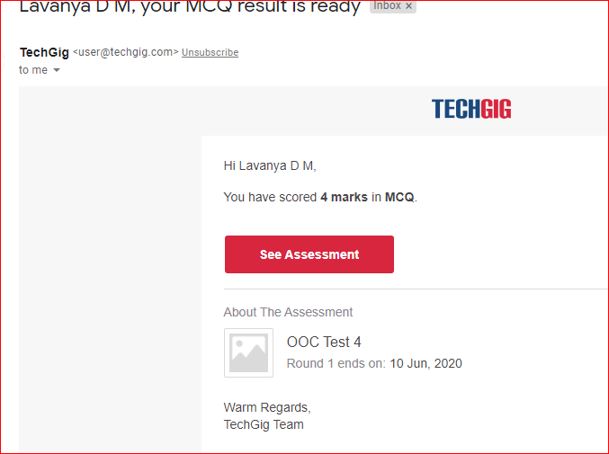

Certification Course Details: (Attach the snapshot and briefly write the report for the same)

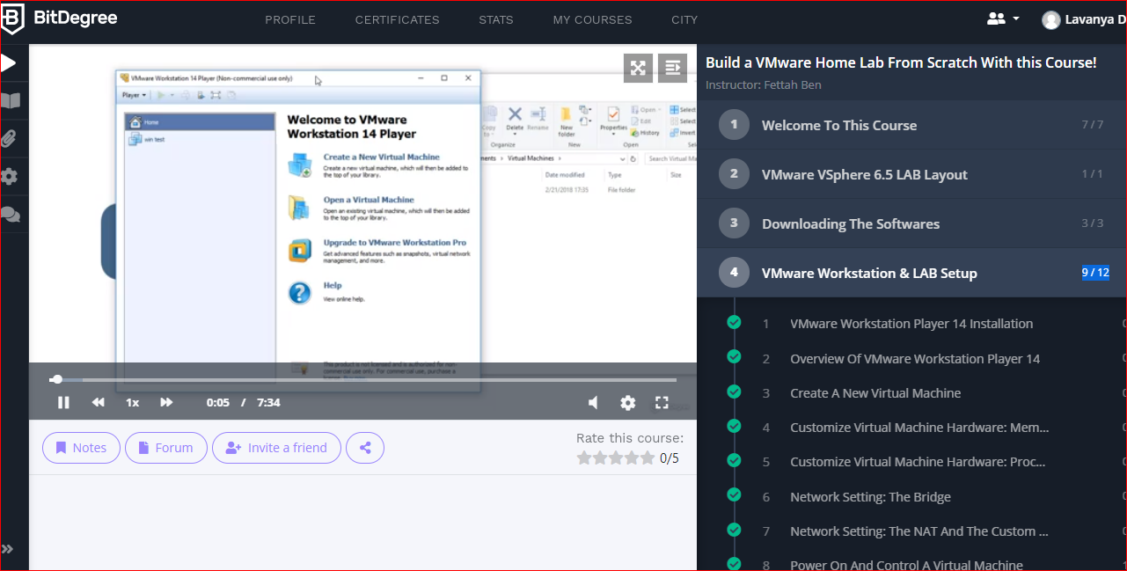Coding Challenges Details: (Attach the snapshot and briefly write the report for the same)

Problem 1: Given a matrix, the task is to print the boundary elements of the matrix and display their sum.  
Sample Output 1:  
Enter M (Rows) and N (Columns): 3, 3  
Enter the Elements: 1 2 3 4 5 6 7 8 9  
OUTPUT:  
The Input Matrix is:  
1 2 3  
4 5 6  
7 8 9  
The Boundary Elements are: 1 2 3 4 6 7 8 9  
The Sum of Boundary elements of the Matrix is: 40

Sample Output 2:  
Enter M (Rows) and N (Columns): 4, 5  
Enter the Elements: 1 2 3 4 5 6 7 8 9 10 11 12 13 14 15 16 17 18 19 20  
OUTPUT:  
The Input Matrix is:  
1 2 3 4  
5 6 7 8  
9 10 11 12  
13 14 15 16  
17 18 19 20  
The Boundary Elements are: 1 2 3 4 5 8 9 12 13 16 17 18 19 20  
The Sum of Boundary elements of the Matrix is: 147

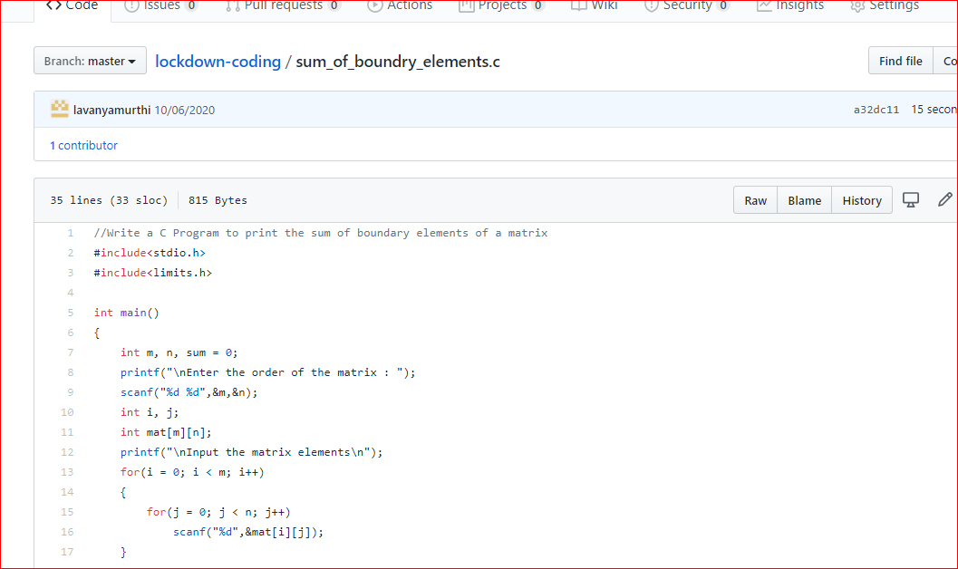

**Problem 2:** Java Program to find the longest repeating sequence in a string  
string:acbdfghybdf

